Wireshark Helper Document

Contents
Font page of wireshark 1
Common Network Interfaces 2
File view in wireshark 3
Filters in Wireshark 4
IP filters: 5
Protocol filters 5
Port filters 6
HTTP filters 6
Filter operators 6

Font page of wireshark
When you first open Wireshark here is what you will see:
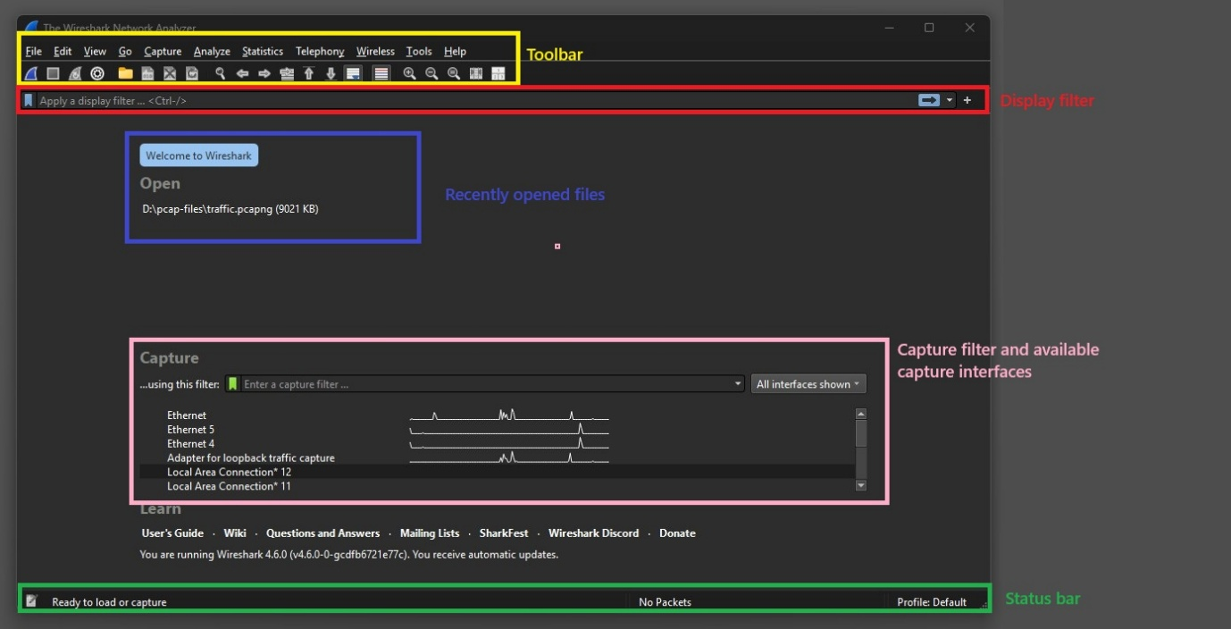

Toolbar: In the toolbar you can find all the tools you can use to open, edit and analyze files like .pcap or .pcapng. These are important and their specificts will be found later on in this document.
Display filter: On the main page the display filter doesn’t do much, but after you have opened a file of packets to look through, you can filter the packets displayed by giving the display filter a rule to follow.
Recently opened files: Here you can find the files you have recently opened
Capture filter and available capture interfaces: Here you can give a capture filter and choose a capturing interface. If you want to create your own pcap (pcap is a file format that stores captured network traffic packets for analysis) files or otherwise sniff internet traffic you can set the filter and choose the interface here and start sniffing by pressing the blue sharkfin on the bottom left of the toolbar area.
Statusbar: Tells you the current status of the program.

Common Network Interfaces
Below is what the common network interfaces usually mean and what is it for.
- eth0: eth0 is typically the main network card of any machine like internet access and LAN communication. In virtual machine, eth0 is mainly used for NAT adapter, bridged adapter and host-only adapter (if assigned)
- eth1: A machine can have multiple network interfaces. eth1 is just the second network card. It's normally used for,
- Additional networks
- Separate VLANs
- Private networks
- Isolated lab enironments
- br0: br0 is a network bridge interface. This bridge mainly works for virtual switch, connecting mutiple interfaces togeter. It can connect VMs, containers and tap devices together. it's used heavily for in virtualization like docker networks, virtual box etc.
- lo: The loopback interface is a virtual network interface isnide every machine. This is not a real physical network card. This is normally used for running local web servers, testing network software, databases etc.
- any: any is wireshark's virtual interface. It's not a real network interface card. It captures traffic from every active interface at the same time. it's useful for troubleshooting when you are not sure where the traffic is going. It can be noisy because it mixes all traffic.
B
scs

File view in wireshark
After opening a file or starting capturing and pressing on a packet you will see something like this:
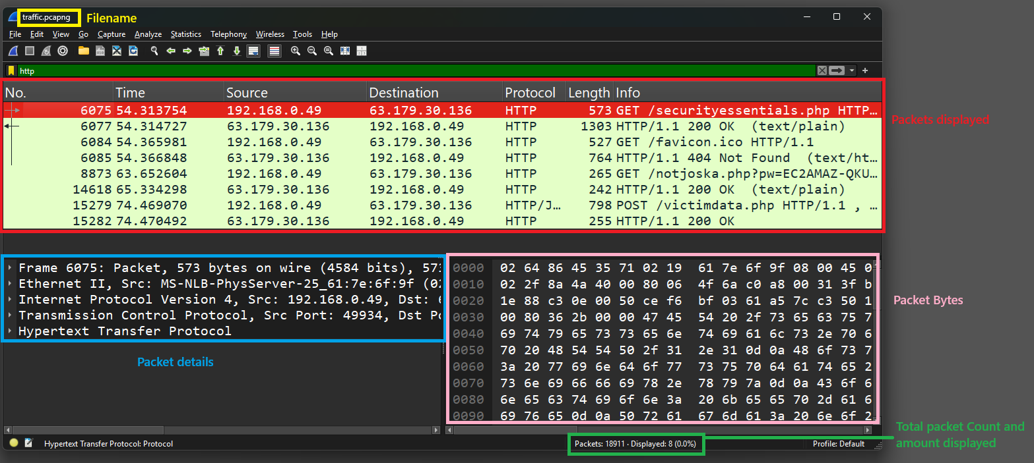
Packets displayed: Shows all the packets that fit the given display filter. Filter in the picture is http so only packets using the HTTP protocol are shown.
Packet details: Here you can find the details of the packet. If the packet is unencrypted, you can easily find all the information it is carrying here.
Packet Bytes: Here you can find the raw bytes of the packet.
Total packet Count and amount displayed: Here you can see the number of packets in the file and how many of them are displayed (displayed packets change according to the display filter).

Filters in Wireshark

Here you can find common filters for capturing and displaying packets.

IP filters:
Get traffic that goes to or comes from IP address 192.168.0.0:
ip.addr == 192.168.0.0

Get traffic coming from IP address 192.168.0.0:
ip.src == 192.168.0.0

Get traffic going to IP address 192.168.0.0:
ip.dst == 192.168.0.0

Get all traffic to any address in the subnet 192.168.0.0/24:
ip.addr == 192.168.0.0/24

Protocol filters

Get all tcp traffic:
tcp

Get all udp traffic:
udp

Get all http traffic:
http

Get all dns traffic:
dns

Port filters

Get all traffic on port 443 (HTTPS):
tcp.port == 443

Get all traffic where source port is 443:
tcp.srcport == 443

HTTP filters

Get all HTTP GET requests (change GET with any other type):
http.request.method == “GET”

Get all HTTP requests with code 404 (page not found):
http.response.code == 404

Get HTTP traffic from host “www.tuni.fi”:
http.host == “www.tuni.fi”

Filter operators

Important operators in Wireshark include:
== (equals: used to mark that a certain variable must have the given value)
Example: ip.addr == 192.168.0.0 - Gives all packets where ip address 192.168.0.0 is source or destination
&& / and: used to combine two rules so that all packets must follow both)
Example: ip.dst == 192.168.0.0 && ip.src == 63.179.30.136
- Gives all packets where destination ip is 192.168.0.0 and source ip is 63.179.30.136
Example: ip.dst == 192.168.0.0 and ip.src == 63.179.30.136
|| / or: used to combine two rules so that all packets must follow at least one or both)
Example: ip.addr == 192.168.0.0 || ip.addr == 63.179.30.136
- Gives the packets that have the ip address 192.168.0.0 or 63.179.30.136
Example: ip.addr == 192.168.0.0 or ip.addr == 63.179.30.136
! / not: used to get the opposite of a given filter
Example: !(ip.addr == 192.168.0.0)
– Gives all packets where IP is not 192.168.0.0
Example: not (ip.addr == 192.168.0.0)

**Warning: If combining more than one &&, || and ! be careful with the order and how you place the parantheses () in the command. These might change the result if not handled with care. Filters using ! might also have many possible interpretations and Wireshark might give you a warning in these situations **

Sources:
Wireshark: Essential Filters for Network Analysis | by IritT | Medium
Try hack me’s Wireshark modules

